JULIANA SILVA
F A S H I O N D E S I G N E R
Fashion designer is who have skill to design clothes from woman, man and children. and I have 6 years experience for designing fashion and forecasting what will be popular with consumers

EXPERIENCE
2018 - 2019
Freelance Fashion Designer
Drawing and Sketching idea or concept of clothing to client’s request
2019 - present Liceria Company
FASHION DESIGNER
Drawing and sketching clothes, accesories, or shoes for consumer and retail companies
Forecasting what will be popular with costumer in one year ahead
Managing team to apply fashion sketch to assemble cloth and it's accesories Colaborating with the wider development team and buyer to develop products

CONTACT
+123-456-7890
hello@reallygreatsite.com www.reallygreatsite.com 123 Anywhere St., Any City

EDUCATION
2014 - 2015 :
Shodwe Certified Academy
Fashion Design

2015 - 2018 :
Larana University
Bachelor Degree of Fashion Design

AWARD
2019 : Best Fashion Designer Given by Salford Magazine

SKILLS
Fashion Illustration
85%
Drawing Sketch
80%
Digital Fashion Drawing
75%
Trend Forecasting

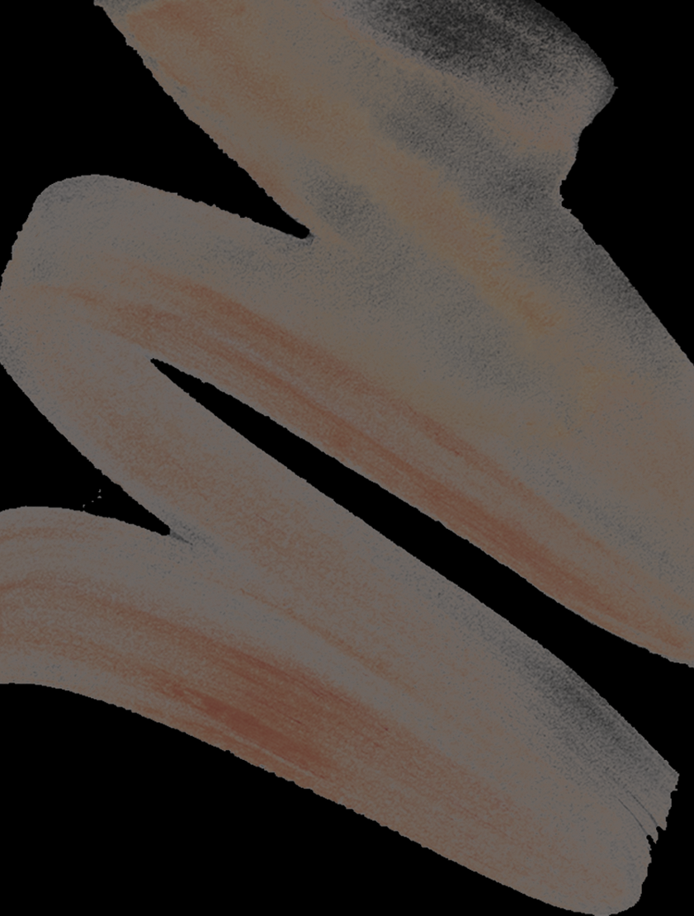75%

